**Differential Gene Expression in Acute Myocardial Infraction**

* 1. How many genes profiled?
     1. 54764
  2. How many samples?
     1. 99
  3. Classes:
     1. M – 49
     2. H – 50
  4. How many remained?
     1. 54717

1. DE
   1. Under the null model what is the expected sum of ranks?
      1. Under the null model, there is no DE between M vs H therefore the probability of one sample to be labeled as H equals to its probability to be labeled as M. In this case half of the samples would be labeled as H and half as M. In that case the sum of ranks will include half of the samples regarding their appearance on the data set. Due to the fact that there are two labels we would expect that the RS(g) will be half of the sum of all the indices.

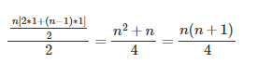

* 1. Minimal value for RS(g)
     1. As explained before half of the samples by probability will be labeled as M. Therefore, the minimal value it can take when n is the number of samples - is when all the first half n samples are labeled as M. which means, summing all the first half n indices.

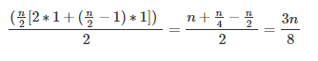

* + 1. The probability of the RS(g) to be m is equal to the probability of the first half n samples the be labeled as M. Each sample has a 50% to be M so it equals to the probability of ordering half of the elements first.

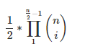

* + 1. The only way that case can be established is when we will shift the last sample labeled as M one index up. It means that the elements in n/2 and n/2+1 positions must be replaced.

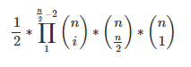

* + 1. The Only way that case can be established is when we will shift the last sample labeled as M two indices upwards. The general formula for these cases when the RS(g) is m+j, j < n/2:

